Request Enrollment Access
Complete the following items online before going to your enrollment location.

- Before enrolling your student, you must request a Skyward Enrollment account by going to the Midland ISD website. Click on “Campus” and select the campus your student will be attending there you will click on “Kindergarten Roundup” then click the link “Click here for online enrollment” to request a Skyward Enrollment account.

IMPORTANT: Please note, an email account is required when requesting a Skyward Enrollment account.

- Complete all required fields (*) and then select Click here to submit Online Enrollment Account Request.

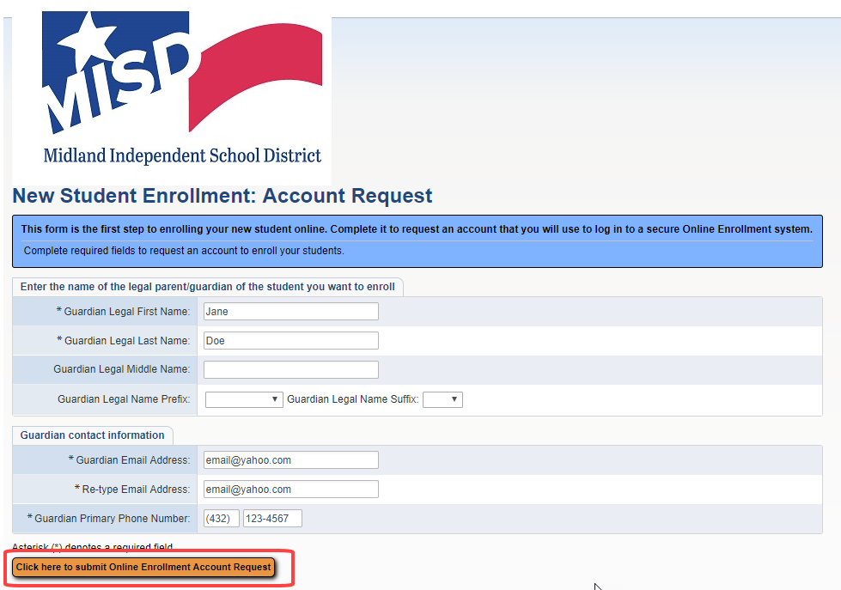

- Read the message and click OK.

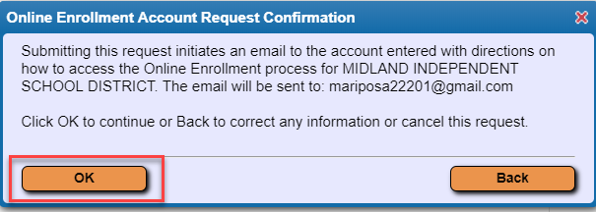

- Read the message and click OK.

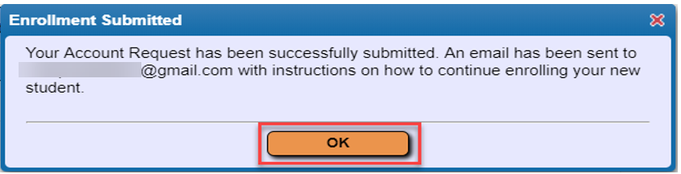

- You will then receive an email message with the link to complete the enrollment process along with your login and password information.

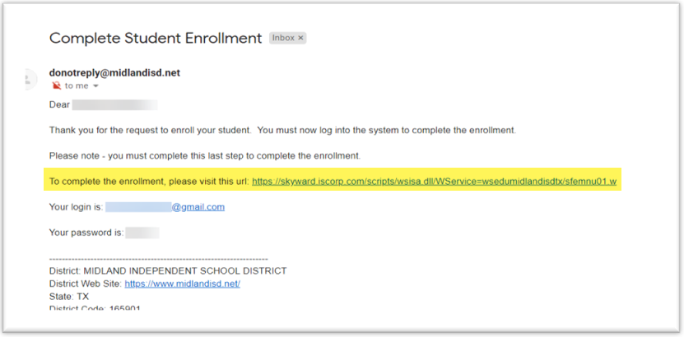

IMPORTANT: Once you receive your Username and Password via email, make sure you write it down and save it for reference. It will not be shown again.

- Enter the Username and Password you received via email and click Sign In.

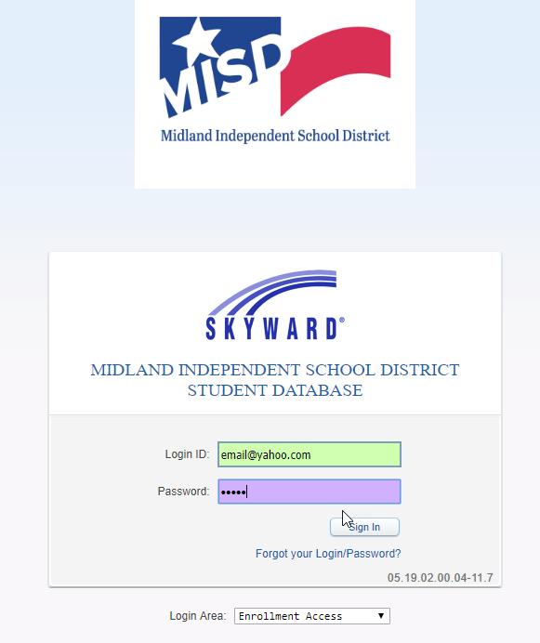

Online Enrollment Application
STEP 1: Student Information

- Enter all required fields (*).
- Select the School Year you are enrolling your child into.

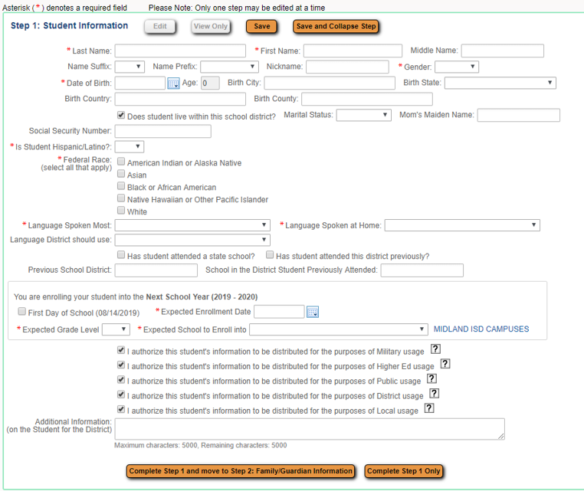

- Once you enter your student’s birth date, the system will automatically calculate the expected grade level. Read the message and click OK.

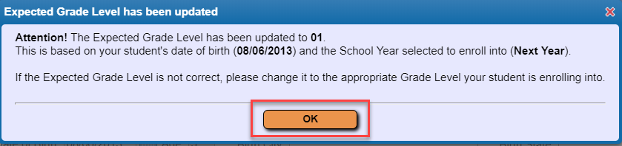

STEP 2: Family/Guardian Information

- Enter all required fields (*).
- To add more than one guardian click Yes, I want to Add another Legal Guardian who lives at this address; otherwise, click No other Legal Guardians live at this address.

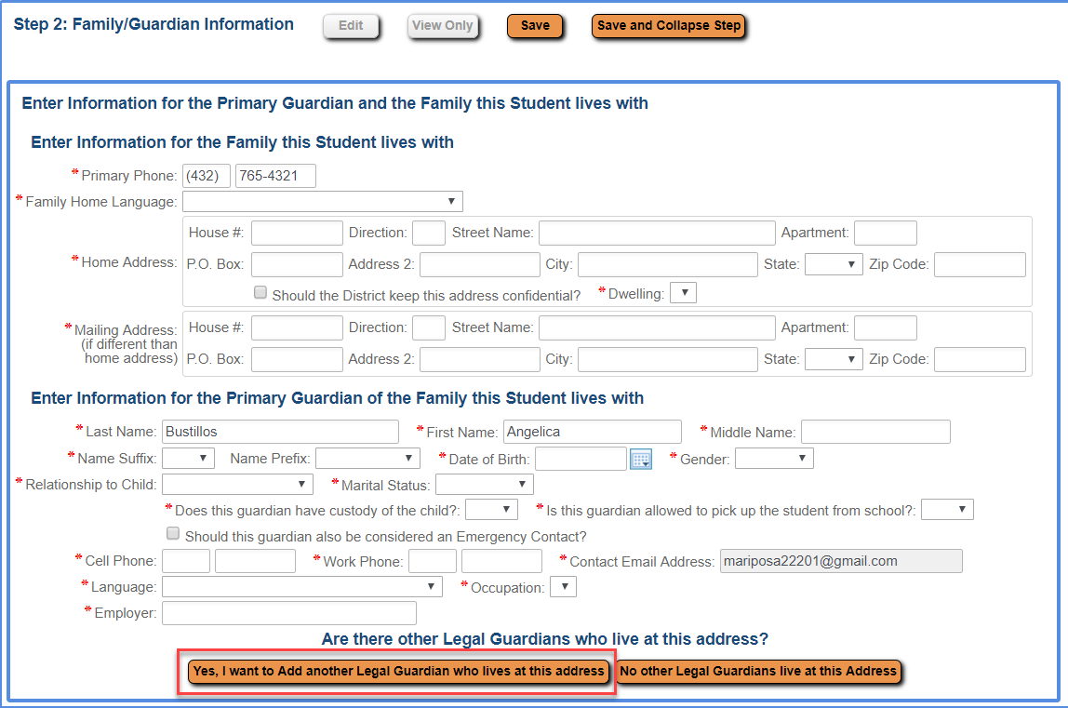

- After all guardians are entered, click No, Complete Step 2 and move to Step 3: Medical/Dental Information.
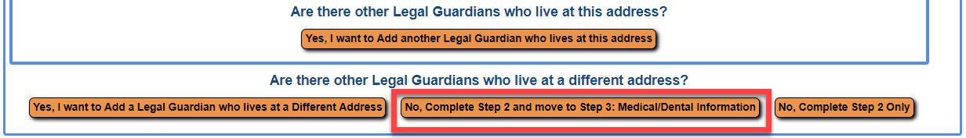

STEP 3: Medical/Dental Information

- Enter all required fields (*).
- Click Complete Step 3 and move to Step 4: Emergency Contact Information.

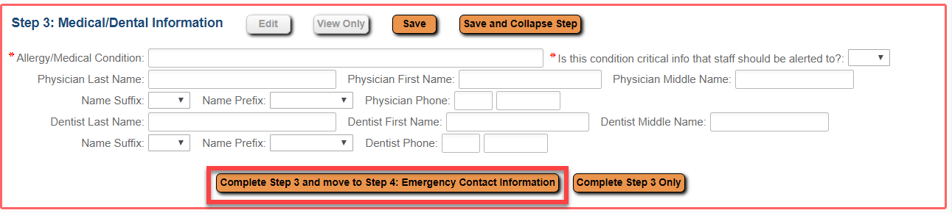

STEP 4: Emergency Contact Information

- Enter all required fields (*).
- To add more than on emergency contact, click Yes, I want to Add another Emergency Contact Record.
- After all emergency contacts are entered, click No, Complete Step 4 and move to Step 5: Immunization Information.

STEP 5: Immunization Information

- If your child has had chickenpox, check the box and fill in the date of the illness.
- Click Complete Step 5 and move to Step 6: Requested Documents.

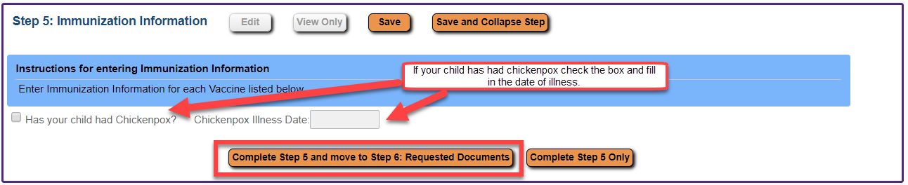

STEP 6: Requested Documents

IMPORTANT: You may upload a copy of your student’s birth certificate, immunization records, proof of residency, social security care, and other documents as needed. However, you must bring the original birth certificate to the school for verification

- OPTIONAL: Upload documents as needed by clicking Choose File.
- After all documents have been uploaded, click Complete Step 6 and move to Step 7: Additional District Forms.

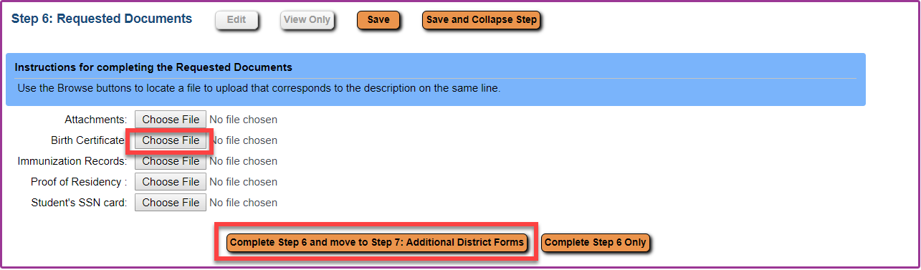

STEP 7: Additional District Forms

- Complete all required forms (*).
- Once finished, click Complete Step 7.

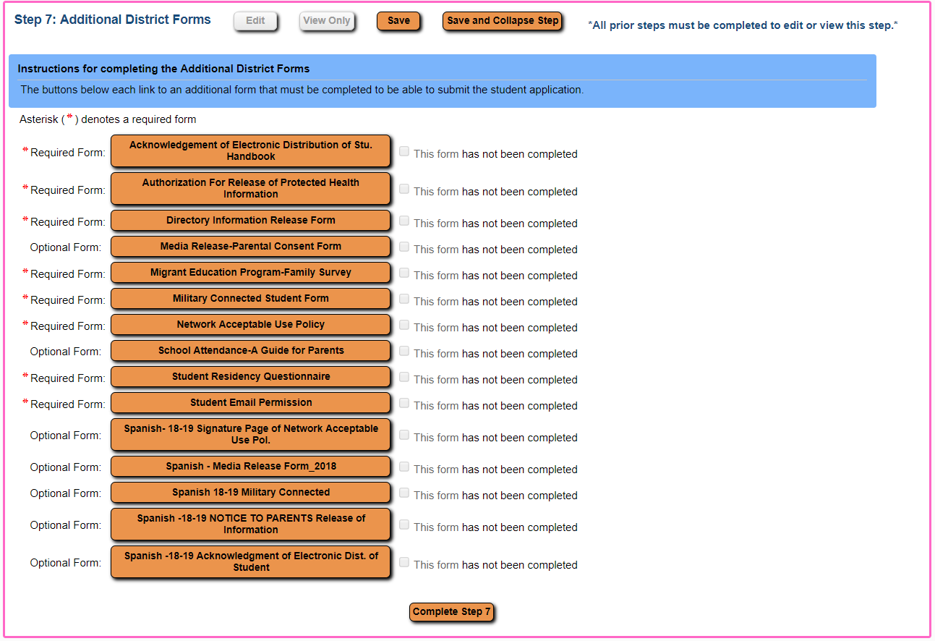

Submit Application

- Once you have completed all Steps, click Submit Application to the District.

- Read the message and click Submit Application.

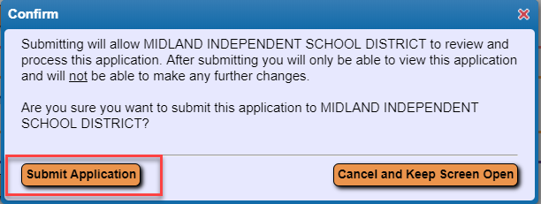

- Read the message and click OK.

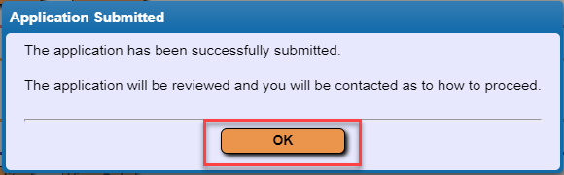

- If you additional students to enroll, select Click to Enroll Additional Students and repeat the instructions from page 1.

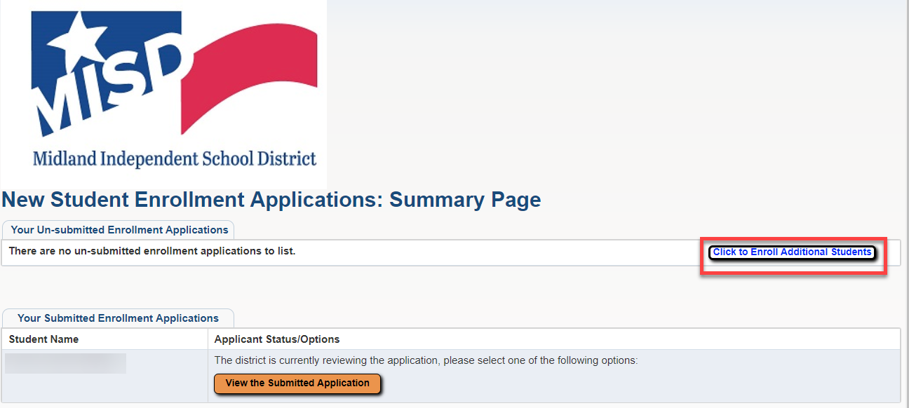

Gather Required Documents

Below are the verification documents required to complete the enrollment process. Gather these verification documents required and bring them to the campus when you enroll.

- Proof of residency in Midland ISD (current gas, light, or water bill with parent/guardian name and address.
- Proof of child’s identity (original birth certificate preferred)
- Transcript/report cards from previous school
- Complete immunization health records
- Student’s Social Security Card (preferred)
- Parent/Guardian Identification (preferred)

