Life Skills 3-6 School Supply List
2018-2019

-3 boxes of Kleenex
-1 box beginner pencils
-1 box of colored pencils
-1 pencil box
-1 package of markers
-2 packages of glue sticks
-3 pack of Clorox wipes
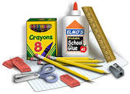
-2 2” or 3” Binders
-1 toothbrush
-1 tube of toothpaste
-1 hairbrush or comb
-1 extra set of clothes

