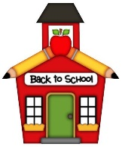Santa Rita Life Skills 3-6 Supply List 2021-2022

2 Composition Books
1 box of Crayola crayons 24 count
2 Packages of Map Colors (colored pencils)
3 Dozen Pencils TICONDEROGA preferable
4 Packages of Notebook Paper
4 Glue Sticks
1 "regular size" bottle of glue
1 pair of Headphones
1 package of white erasers
4 boxes of Kleenex
2- 2” Binders/Organizer
Cloth Pencil Pouch
Plastic School box
2 packs of Sticky Notes
Scissors
Pack of white pencil cap erasers
1 package of Expo markers (black)

